
2025

IFAMS Modernization

SAP S/4HANA Development Standards

Version 1.0
01/12/2025

Document Information
Project Name | IFAMS Modernization
Document Name | SAP S/4HANA Development Standards
Project Director | Vincent Ho
Project Manager | Matthew Lee
Document Version No. | 1.0 | Document Version Date | 01.12.2025
Prepared by | Surya Wijaya | Submission Date | 01.12.2025
Reviewed by | Wan Mohd Faisal bin Wan Ismail | Review Date
Comment(s) | N/A

Contact for Enquiries and Proposed Changes
For any questions regarding this document please contact:
Name: | Wan Mohd Faisal bin Wan Ismail
Title/Role: | EPF Technical Lead
Department: | IT
Email: | faisal-wi@epf.gov.my

Revision History
Version | Revision Date | Description of / Reason for change | Author (name and role)
1.0 | 15.04.2025 | First draft | Surya Wijaya

Review History
Version | Reviewer Name | Title/Position | Date Reviewed
1.0 | Wan Mohd Faisal bin Wan Ismail | EPF Technical Lead

Approval History
Version | Approver Name | Title/Position | Date Approved
1.0

Table of Contents
1. Introduction 11
1.1. Purpose 11
1.2. Audience 11
1.3. Document Scope 11
2. Quality 12
2.1. ABAP Code Quality Assurance 12
2.2. Technical Specification Documentation 12
2.3. Extended Program Check 12
2.4. ATC Check 13
3. Best Practices 14
3.1. Introduction 14
3.2. Programming Techniques and Modularization 14
3.3. Code Push down 14
3.4. Database Access and Memory Usage 15
3.5. In-Memory optimization 15
3.6. Error Handling 15
3.7. Multilingual Support Texts 16
3.8. Readability 16
3.9. Reusability 16
3.10. Flower Box 16
3.11. Modification Tag 17
4. Naming Convention 18
4.1. Package 18
4.2. Data Dictionary 18
4.3. ABAP Programming Objects 19
4.4. Conventions for Data Declarations 19
4.5. ABAP Object Oriented 21
4.6. CDS 22
4.7. Workflow 22
4.8. Messages 23
4.9. Web Service 23
4.10. Transport 24
4.11. Functional Code 24
4.12. Functional Component Area 25
5. SAP Fiori 27
5.1. Overview 27
5.2. SAP Fiori Apps 27
5.3. System Landscape 27
5.4. Odata Service Naming Standards 31
5.5. SAP Fiori App Implementation 31
5.5.1. Project Creation 31
5.5.2. Fiori Application Naming Standard 32
5.6. Version Management 33
5.6.1 GitHub 33
5.6.1 Committing New Application 34
5.6.2 Committing Modified Application 35
5.7. Java Script Coding Guidelines 35
5.8. Code Formatting 35
5.9. Internalization 36
5.9.1 Resource Bundles 36
5.10. Naming Conventions 37
5.11. Coding Issues to be Avoided 38
5.12. SAPUI5 Adaptation 39
5.12.1. Fiori Adaptation Naming Standard 40
5.13. Gateway Development Process 40
5.13.1. Create New Service Endpoint 40
5.13.2. Business API Interface Structures 40
5.13.3. Create GW Object Structure in DDIC 40
5.13.4. Build Optional Association Between GW Objects 41
5.13.5. Generate GW service 41
5.13.6. Implement relevant methods in the DPC_EXT class 41
5.13.7. Test changes 41
6. Extensibility Guidelines 42
6.1. Decision Guidelines for Extensibility Options 42
6.2. Key User Extensibility 44
6.2.1. UI Flexibility 44
6.2.2. Custom Field 44
6.2.3. Custom Logic 44
6.2.4. Custom Analytical Queries 44
6.3. Developer Extensibility 45
6.3.1. Overview 45
6.4. CAR Extensibility 45
6.4.1. Overview 45

Introduction

Purpose
The document provides:
- Rules and general guidelines to achieve a uniform way of developing, documenting and maintaining custom repository objects to be developed in the project.
- Rules and guidelines on quality assurance for development objects – ABAP and Fiori
- Checklists of demands for developments in order to make the acceptance of developments measurable.

Audience
The document is intended for development team, client support team and SAP support team.

Document Scope
The document covers the following areas:
- ABAP and Fiori / UI5Coding Best practices
- ABAP and Fiori Code naming standards
- Quality Assurance approach

Quality
Quality Assurance and Control consists of two distinct parts:
- Deliverables – the documentation that will be delivered with each development.
- Conventions - static coding rules that the deliverables must adhere to

ABAP Code Quality Assurance
A number of processes should be put in place to ensure all ABAP code developed is of the appropriate ‘productive’ standard. The key areas are covered in this section. The remaining sections of this document provide greater detail for some of these areas. The Code as well as technical specification will be reviewed by the ABAP development team as part of peer review process.

Technical Specification Documentation
All the developments must have an appropriate design phase. The first step in the design process will be the identification of the business requirement by the functional team. There would be one document used for Functional and Technical Specifications with respective sections for these. The functional process owner will be responsible for detailing the requirement in a specification in the Functional Section. The technical team will use this specification as a basis for the technical design. The technical design details will be documented in the technical section of the same Functional and Technical Specification This document will then be the key support document for the development once it is in the live system. The full technical specification will only be delivered once the development/testing has been completed.
The specification will be subject to a quality review to ensure that it contains the appropriate level of detail for supporting the development. It will also adhere to the following standards:
- Technical specification will list all development objects created in order to meet the requirement
- If Code samples are considered useful and relevant to the document, make sure they are not screen prints; rather make sure they are editable text.
- If Code samples are used make sure they only contain the most relevant code and are explained in text exactly what the sample of code is doing. If the Sample of text is long, then break it up with clear text explanations.
- Ensure document contains any key decisions made and the rationale behind it. If any alternate options were considered, make sure these are also documented with a reason why it was rejected.
- Program flow diagrams are not mandatory as they are time consuming and difficult to keep up to date, however in some cases they are extremely useful and valuable, if this is the case make sure to include them.
- For Form development, the functional design should include mock-ups (screen layouts). The technical design should also include these with notes/annotations as required.

Extended Program Check
Before a development is transported to the test environment, the extended program check must be performed. All errors and warnings should be checked and cleared.
All remaining warning messages which cannot be cleared must be explained by the business requirements and then commented out by pseudo code. General information

ATC Check
Use of ATC is mandatory for quality checks of all new developments and changes made in SAP GUI. ATC checks will be called for every custom ABAP object created or modified.
Cloud Readiness Check and S4 Readiness check variants will be used for performing the ATC checks and extended program check on the transport request which are created for SAP GUI development.

Best Practices

Introduction
Over a period with the evolution of SAP from 4.7 to ECC and then to S/4 HANA, several features have been changed so far. With the arrival of new frameworks, screens, and guidelines, several modern practices are developed, and they are adopted in many modules, customization, and in programming.
However, there might be situations where deviating from these rules might provide a better solution to the problem. In case of any clarification required, the issue should be discussed in the DA.

Programming Techniques and Modularization
With every new release SAP introduces new programming techniques and declares others obsolete. Make sure you always make use of the full capabilities of the release you are working on. All ABAP including BTP changes are documented in the release notes. Please reads those carefully.
A program should always be modalized in such a way that the main parts of the program are clearly separated. This improves both readability and reusability. The minimum separation must be between:
- Selection of data
- Processing of data
- Presenting output
- Saving changes to the database
The source code should be separated into units with a clear function and with a name, which describes that function.

Code Push down
ABAP (development) for SAP HANA refers to all developments which leverage the power of SAP HANA within ABAP-based applications. In this context, the SAP HANA platform is the primary database underlying the ABAP platform. This system deployment option is supported from ABAP 7.4 onwards.
The introduction of the SAP HANA platform in the ABAP universe has brought a shift in the application programming paradigm. The general rule of thumb here is quite simple: "Do as much as you can in the database to get the best performance – but at same time, avoid unnecessary burden to the database".
The classical application programming paradigm, data-to-code, where a huge amount of data is fetched from the database, stored in internal tables and then processed on the application server, shifts to the in-memory database-powered code-to-data programming paradigm (aka code pushdown), where data-intensive computations are delegated to the database and only the result sets sent back to the application server. This reduces both memory consumption and workload on the application server, as well as the network load.

Database Access and Memory Usage
A global temporary table (GTT) can only be filled with temporary data during a database Logical Unit of Work (LUW). When a GTT is filled using Open SQL, it must be emptied again explicitly before the next implicit database commit. If not, a non-handleable exception is raised.
- Keep the number of hits low
You can use specific conditions to restrict the set to those rows needed, it will help you to keep the set of selected rows as small as possible.
- Keep the data volume low
A restricted number of the columns always can improve the performance; therefore you should request only the columns which will be really used, no superfluous columns. In the same way, you can use aggregate functions to reduce the volume of data.
- Keep the number of reads low
Mass operations are better than single operations, therefore the Open SQL statements should not be used within loops. Instead, joins, views, or subqueries can be used when reading multiple database tables.
Use The New Open SQL Functions in Order to Reduce the Number of Operations in ABAP. See the functions below:
New numeric function ROUND: it rounds numeric values.
New string functions: CONCAT, LPAD, LENGTH, LTRIM, RTRIM, REPLACE, RIGHT and SUBSTRING.
Various code pushdown programming techniques, with different levels of utilization of the advanced native SAP HANA capabilities, are available in the ABAP platform. A CDS (Core Data Services) can be assigned as a replacement object to a transparent database table or a classic database view. In Open SQL reads, the replacement object is then accessed instead of the original object.

In-Memory optimization
ALV with IDA offers an in-memory optimized variant of the well-known ALV re-use component. With the new component, all data-centric UI operations such as sorting, grouping or aggregating are delegated to the database and thus always processed on the full data set. Constraints such as authorizations and value ranges are declared and evaluated directly on the database, and the database paging is used on SAP HANA so that only visible data is fetched from the database.
Be specific about the type of internal table declaration. The default is not always to declare the internal table as the standard type. In fact, one must invest some time to decide which category the internal table is falling:
- Sorted internal table with Unique Key
- Sorted internal table with non-unique key components X Y
- Sorted internal table with non-unique sorted key components A B C
- Hashed Table with Unique Key

Error Handling
Improve the Error Handling in your ABAP Code Using New Features in Exception Classes. When you add one of the following ABAP super classes (CX_STATIC_CHECK, CX_DYNAMIC_CHECK, CX_NO_CHECK), then an ABAP exception class is automatically created. Catch class-based exceptions in the statement block enclosed by the TRY and ENDTRY statements are must.

Multilingual Support Texts
The default language to develop custom objects is English.
This means that all objects created must have English as the Original Language in their attributes:
- All texts must be translatable. This is needed for expected output in the Market's preferred language.
- The Texts must not be hardcoded in the code
- The Texts required in forms or mail body, should be maintained in the SO10 (as Standard Texts)
- Program texts for report column headers, selection screens etc. should be maintained as text elements
in the program.

Readability
When a custom development is created, no matter how big or small, it should be considered that someone else will be supporting and maintaining it. This means that everything developed must be readable and understandable by everyone else. This places a high emphasis on clean, well-structured and well documented source code. Intelligible programs tend to have less bugs and save money in the long run.
Understanding of code can be increased when using:
- Inline Documentation. Make it meaningful: explain what you are trying to achieve functionally and elaborate on technical difficulties and quirky bits.
- Headers with details on the work done in the program (like author, date, revision marker and details of the change)
- Revision markers. Never delete code in an already productive program but comment the faulty code and add the revised code below. Also add comments to state why the change was done.
- Pretty Printer - with automatic indentation and keywords in uppercase.

Reusability
An action should always be programmed just once. Therefore, when a solution is designed that needs to perform the same action more than once, it should be placed in a reusable unit. Global classes are the reusable objects of choice, but dependent on the use of the reusable unit, other options may be chosen as well. Keep the MVC design concept in mind when choosing which method suits your requirement best.

Flower Box
The following program header should be used when creating a new Program. This pattern should also be used in class methods, enhancement spots and any other place where custom code is inserted.
*======================================================================*
*Confidential and Proprietary
*IFAMS Modernization
*----------------------------------------------------------------------*
*Program Name : <Program Name>
*RICEF ID : <RICEFW ID>
*Created on : DD.MM.YYYY
*Created by : (<User ID>) <Full Name> ABAP Developer
*Functional : (<User ID>) <Full Name> Functional Analyst
*Description : <Description of changes>
*======================================================================*
* M O D I F I C A T I O N L O G
*----------------------------------------------------------------------*
* 01. Changed on : DD.MM.YYYY
* Changed by : (<User ID>) <Full Name>
* Change No. : <Transport Number>
* Modif. Tag : MOD<3 Digit Incremental Number>
* Description : <Description of changes>
*======================================================================*

Modification Tag
The modification tag should be added to the block of code inserted, changed, and deleted.
The format will be <Modif Tag>.Begin.<Insert/Change/Delete> / <Modif Tag>.End.<Insert/Change/Delete>.
For adding or deleting one line, format will be <Modif Tab>.<Insert/Delete>
Adding new block of code | “MOD001.Begin.Insert  <Block of code>  “MOD001.End.Insert
Changing existing logic | “MOD001.Begin.Change  “<Existing code> “Make sure to comment out existing codes to be replaced  <New block of code>  “MOD001.End.Change
Commenting out existing logic | “MOD001.Begin.Delete  “<Existing code line 1>  “<Existing code line 2>  “MOD001.End.Delete
Adding one line of code | <Line of code> “MOD001.Insert
Commenting one line of code | “<Line of code> “MOD001.Delete

Naming Convention

Package
All custom developments must be assigned to a package. The naming conversion of packages are mainly of only one type and shall be based on the usage of the development under that package.
Package Element | Naming Convention | Example / Remarks
Global | <Z><APPL> | ZSD, ZFI

- <Z> - Hardcoded value
- <APPL>- Refer Application Area

Data Dictionary
A table consists of columns (data values of the same type) and rows (data records). One or several fields can identify each record uniquely.
- <IDT> - Identifier (Hardcoded to ‘Z’)
- <FC> - Functional Code (Refer to section 4.11)
- <CA> - Component Area (Refer to section 4.12)
- <TYPE> - Type of DDIC objects
- <FREETEXT> - Meaningful free text
Type of DDIC Objects | <TYPE>
Database table | T
Global Temporary table | GT
Structure | S
Views | V
Table type | T_T
Domain | DO
Data element | DE
Search Help | SH

Dictionary Element | Naming Convention | Example / Remarks
Database table | <IDT><FC><CA><TYPE>_<TEXT> | ZFGLT_GENERAL_LEDGER
Global Temporary Table | <IDT><FC><CA><TYPE>_<TEXT> | ZFGLGT_GENERAL_LEDGER
Structure | <IDT><FC><CA><TYPE>_<TEXT> | ZFGLS_GENERAL_LEDGER
Views | <IDT><FC><CA><TYPE>_<TEXT> | ZFGLV_GENERAL_LEDGER
Table type | <IDT><FC><CA><TYPE>_<TEXT> | ZFGLT_TGENLEDGER
Domain | <IDT><TYPE>_<TEXT> | ZDO_QUANTITY
Data element | <IDT><TYPE>_<TEXT> | ZDE_QUANTITY
Search help | <IDT><FC><CA><TYPE>_<TEXT> | ZFGLSH_COSTCENTER
Lock Object | <E><IDT>_<DB TABLE> | EZ_SFLIGHT

ABAP Programming Objects
Object Type | Naming Convention | Example / Remarks
Transaction Code | <IDT><FC><CA>_<TEXT> | ZMIM_PRINT_PI_DOC
Executable Program | <IDT><FC><CA><PT>_<TEXT> | ZVSLR_SO_TRACKING  <PT> = Program Type:  R = Report  I = Interface  C = Conversion  E = Extension / Enhancement  F = Forms / Print Program  W = Workflow  X = Cross Program / Include
Temporary Program (Not to be transported) | <Y><IDT><INIT>_<TEXT> | YZBGT_SO_TRACKING  <INIT> = Developer Initials
Module Pool
Includes | <IDT><FC><CA>X_<TEXT> | ZVSLX_SO_TRACKING_TOP  ZVSLX_SO_TRACKING_F01  ZVSLX_SO_TRACKING_S01
Includes
Function Group | <IDT><FC><CA>_<TEXT> | ZFGL_WPL_JV
Function Module | <IDT>_<FC><CA>_<TEXT> | Z_FGL_CONVERT_CURRENCY_TO_POUNDS
BADI Definition | ZED_<FC><CA>_BADI_<TEXT> | ZED_MPU_BADI_PURCH_REQ
BADI Implementation | ZEI_<FC><CA>_BADI_<TEXT> | ZEI_MPU_ BADI_PURCH_REQ
BADI implementation  Class | ZCL_IM_<FC><CA>_<TEXT> | ZCL_IM_MPU_ PURCH_REQ
BSP Application | ZUI_<FC><CA>_<TEXT> | ZUI_MPU_PO_REPORT

Conventions for Data Declarations
The naming convention for data declarations will be followed for new objects. For existing objects, follow the existing nomenclatures and naming patterns that the object is using even when declaring new variables.
There are the following general naming conventions for variables:
- <VIS> - Visibility
- <DT> - Data Type
<VISIBILITY><DT>_<FREETEXT>
<VIS> | <DATA Types>
  L | Local
  G | Global
  IM | Import
  EX | Export
  P | Changing/Using
  T | Table (Only for FM not  in use for subroutines)
  V | Variable
  S | Work Area
  T | Internal Table
  TY | Types
  TY_T | Table Type
  FS | Field Symbol
  C | Constant
  S | Structure
  P | Parameter
  S | Select Option
  R | Range
  CB | Check Box
  RB | Radio Button
  EX | Exceptions
Examples:
Variables | Used for
LC_<FREETEXT> | Local Constant
GC_<FREETEXT> | Global Constant
LV_<FREETEXT> | Local Variable
GV_<FREETEXT> | Global Variable
LT_<FREETEXT> | Local Internal Table
GT_<FREETEXT> | Global Internal Table
LS_<FREETEXT> | Local Work Area
GS_<FREETEXT> | Global Work Area
LTY_<FREETEXT> | Local Type
TY_<FREETEXT> | Global Type
LTY_T_<FREETEXT> | Local Table Type
TY_T_<FREETEXT> | Global Table Type
<FS_<FREETEXT>> | Global Field symbol
<LFS_<FREETEXT>> | Local Field symbol
IV_<FREETEXT> | FM / Subroutine Import Parameter for single value
EV_<FREETEXT> | FM / Subroutine Export Parameter for single value
CV_<FREETEXT> | FM / Subroutine Changing Parameter for single value
IT_<FREETEXT> | FM / Subroutine Import Parameter for internal table
ET_<FREETEXT> | FM / Subroutine Export Parameter for internal table
CT_<FREETEXT> | FM / Subroutine Changing Parameter for internal table
T_<FREETEXT> | FM / Subroutine Table Parameter for internal table
IS_<FREETEXT> | FM / Subroutine Import Parameter for structure
ES_<FREETEXT> | FM / Subroutine Export Parameter for structure
CS_<FREETEXT> | FM / Subroutine Changing Parameter for structure
T_<FREETEXT> | FM / Subroutine Table Parameter for structure
P_<FREETEXT> | Selection Screen Parameter
S_<FREETEXT> | Select Option
GO_<FREETEXT> | Global Object instance
LO_<FREETEXT> | Local Object Instance

ABAP Object Oriented
Object Type | Naming Convention | Example / Remarks
Global Class | ZCL_<FC><CA>_<FREETEXT> | ZCL_MPU_PURCH_REQ_ITEM_PROC
Global Interface | ZIF_<FC><CA>_<FREETEXT> | ZIF_MPU_PURCH_REQ_ITEM_PROC
Local Class | LCL_<FREETEXT> | LCL_ PURCH_REQ_ITEM_PROC
Local Interface | LIF_FREETEXT> | LIF_ PURCH_REQ_ITEM_PROC
For method parameters kindly follow the Function module parameter naming conventions
- <IDT> - Identifier (Hardcoded to ‘Z’)
- <FC> - Functional Code (Refer to section 4.11)
- <CA> - Component Area (Refer to section 4.12)
- <FREETEXT> - Meaningful free text

CDS
Object Type | Naming Convention | Example / Remarks
Basic Interface View | <IDT>_<FC><CA>_<CTYPE>_<FREETEXT> | ZCDS_MPU_I_SALESORDERDATA
Composite Interface View | <IDT>_<FC><CA>_<CTYPE>_<FREETEXT> | ZCDS_MPU_X_SALESORDERDATA
Consumption View | <IDT>_<FC><CA>_<CTYPE>_<FREETEXT> | ZCDS_MPU_C_SALESORDERDATA
Analytical View | <IDT>_<FC><CA>_<CTYPE>_<FREETEXT> | ZCDS_MPU_A_SALESORDERDATA
Custom Extension View for Basic/Composite Interface View | <ZIDT>_<CDS Name>_EXT | ZCDS_I_MATERIAL_EXT
Custom Extension View for Consumption View | <ZIDT>_<CDS Name>_EXT | ZCDS_C_MATERIAL_EXT
AMDP Class | Use Naming Convention of Class  & Method
Table Function | Use Naming Convention of Interface View
- <IDT> - Identifier (Hardcoded to ‘ZCDS’)
- <CTYPE> - CDS Type
  - I – Interface View
  - C – Consumption View
  - X – Composite View
  - A – Analytical View
- <FC> - Functional Code (Refer to section 4.11)
- <CA> - Component Area (Refer to section 4.12)
- <FREETEXT> - Meaningful Text (only 5 character)

Workflow
Object Type | Naming Convention | Example / Remarks
Workflow abbreviation | <IDT><FC>CA><PT>_<FREETEXT> | ZMPUW_POAPP

- <IDT> - Identifier (Hardcoded to ‘Z’)
- <FC> - Functional Code (Refer to section 4.11)
- <CA> - Component Area (Refer to section 4.12)
- <PT> = Program Type (W for Workflow)
- <FREETEXT> - Meaningful Text (only 5 character)

Messages
The purpose of this section is to define the naming conventions to be used for standard messaging in SAP. Standard SAP messages should be used whenever possible to eliminate redundancy. If no standard message exists, create a new message according to the guidelines described in this section.
The MESSAGE ABAP statement is used to send messages in the logon language of the current user. Messages are language-dependent single texts that are stored in T100 database table and can be maintained in Transaction SE91.
Object Type | Naming Convention | Example / Remarks
Message Class | <IDT><FC>_EPF | ZF_EPF

- <IDT> - Identifier (Hardcoded to ‘Z’)
- <FC> - Functional Code (Refer to section 4.11)

Web Service
Object Type | Naming Convention | Example / Remarks
Proxy Object | SI_<FREETEXT> | When creating, no need to include PREFIX. Enter name with correct naming conversion and when asked for prefix, use <PREFIX> naming convention  Without Prefix SI_StockFigureQuery_Proxy
Web Service Definition | <IDT>_<Proxy Object Name>_Proxy | Name is generated upon creation of Proxy object but need to add _Proxy as a suffix. This is only applicable for Service Provider  ZSI_StockFigureQuery_Proxy
Interface | <PREFIX>II_<FREETEXT> | This is usually auto generated based on the Proxy Object Name  ZI030II_SI_STOCK_FIGURE_QUERY
Class | <PREFIX>CL_<FREETEXT> | This is usually auto generated based on the Proxy Object Name  ZI030CL_SI_STOCK_FIGURE_QUERY2
Message Type | <PREFIX>MT_<FREETEXT> | This is usually auto generated based on the Proxy Object Name  ZI030MT_STOCK_FIGURE_QUERY_REQ
Global Data Type | <PREFIX>DT_<FREETEXT> | This is usually auto generated based on the Proxy Object Name  ZI030DT_STOCK_FIGURE_QUERY_REQ
SOA Manager Service | <IDT>_<Proxy Object Name>_SVC | ZI030_STOCKFIGUREQUERY_SVC
SOA Manager Binding | <IDT>_<Proxy Object Name>_BIND | ZI030_STOCKFIGUREQUERY_BIND

- <IDT> - Identifier (Hardcoded to ‘Z’)
- <PREFIX> - PREFIX (Z<RICEFWID><CA>)
- <CA> - Component Area (Refer to section 4.12)
- <FREETEXT> - Meaningful Text

Transport
Object Type | Naming Convention | Example / Remarks
Workbench Transport | <RICEFWID>:<FREETEXT>_<VERSION> | I_SLC_001:Sales_Order_Upload_1.0
Customizing Transport | <CA>:<FREETEXT>_<VERSION> | SL:Price_Routine_1.0
Transport of Copies | <TOC>_<MAIN_TR> | TOC: I_SLC_001:Sales_Order_Upload_1.0

- <CA> - Component Area (Refer to section 4.12)
- <RICEFW> - RICEFW ID
- <FREETEXT> - Meaningful free text
- <VERSION> - 1.0, 1.1, 2.0
- <TOC> - Hardcoded value

Functional Code
Functional Code | Description
F | Financial Accounting
K | Cost Accounting
P | Project System
R | Retail
I | Inventory Management
D | Merchandise and Inventory Management
O | Point of Sales Data Management / Customer Activity Repository (CAR)
V | Sales and Distribution
S | BASIS
W | Business Information Warehouse
Z | Programmer Work ABAP

Functional Component Area
Functional Code | Component | Description
F | GL | General Ledger
F | AP | Accounts Payable
F | AR | Accounts Receivable
F | AA | Asset Accounting
F | BA | Bank Accounting
F | CS | Cash Management
F | NG | New GL
F | TX | Tax
K | FM | Fund Management
K | CC | Cost Center
K | IO | Internal Order
K | PC | Profitability & Cost Management (PCM)
P | PS | Project System
R | MD | Master Data
R | PR | Procurement
R | AL | Allocation
R | RP | Replenishment
R | PI | Pricing
R | PM | Promotion
R | IV | Invoices
I | IM | Inventory Management
D | MI | MIM
O | PO | POSDM / POSDTA
O | DF | Unified Demand Forecast
O | DD | Demand Data Foundation
O | OP | Omnichannel Promotion Pricing
O | OA | On-shelf Availability
V | MD | Master Data
V | SL | Sales
V | DL | Delivery
V | BL | Billing
V | CR | Credit Management
S | CA | Cross Applications
S | SC | Security
S | UP | Upgrade Tools/Utilities
W | EX | BW Extracts
Z | CA | Technical ABAP / Cross Application
Z | XX | General Unclassified

SAP Fiori

Overview
SAP Fiori is the new user experience (UX) for SAP software, built by applying modern design principles. SAP solutions are using the SAP Fiori UX to provide a personalized, responsive, and simple user experience.
SAP Fiori UX speaks a consistent design language and makes use of a common technical infrastructure. By blurring traditional computing boundaries and by using interactive and attractive UI elements, SAP Fiori UX provides a consistent end-to-end user experience and can be used across all device types (for example, desktop, tablet, and mobile).

SAP Fiori Apps
SAP Fiori apps are platform-independent web apps, built with SAPUI5 for mobile and desktop devices. They run in the SAP Fiori launchpad, the back end connects by using OData services. SAP Fiori apps apply the SAP Fiori user experience design principles (role-based, adaptive, simple, coherent, and delightful). They are available for different SAP roles.
The front-end components of SAP Fiori apps are deployed on SAP Fiori front-end server and support the principles of enterprise lifecycle management. SAP Fiori apps allow to create modification-free extensions for predefined extensibility use cases.
Organized by user roles, the SAP Fiori launchpad is the central entry hub to all SAP Fiori apps, where users access apps via tiles. Within the launchpad, there are services for navigation, personalization, single sign-on, and search.
In addition to SAP Fiori apps using SAPUI5 as the UI technology, there are classic applications using different UI technologies, such as Web Dynpro or SAP GUI. These classic applications do not fulfill all of the criteria of SAP Fiori apps. They can be called from the SAP Fiori launchpad and must be configured specifically.

System Landscape
As per SAP ‘s recommendations for On-premise SAP system, Fiori FES needs to be setup following the embedded approach
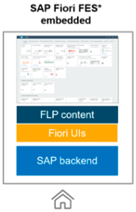

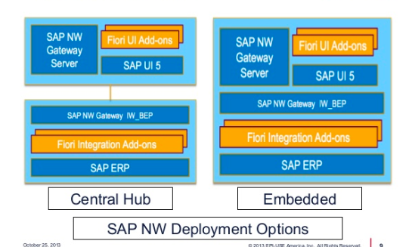
SAP Web Dispatcher
SAP Fiori apps are processed as follows: First, the client loads the UIs for the SAP Fiori apps. Second, while running, the app consumes data from the back-end systems.
The SAP Fiori apps send requests to several systems, depending on the application type and the connected system landscape.
Standard browsers have a “same origin” policy, that is, HTTPS requests for the UI data and the back-end data must communicate with just one web address.
ABAP Front-End Server
The ABAP front-end server contains all the infrastructure components to generate an SAP Fiori app-specific UI for the client and to communicate with the back-end systems. The UI components and the gateway are based on SAP NetWeaver. Typically, both are deployed on the same server.
SAP Gateway handles the communication between the client and the back end. SAP Gateway uses OData services to provide back-end data and functions and processes HTTPS requests for OData services.
ABAP Back-End Server
On the ABAP back-end server, the products that provide the business logic and the back-end data, including users, roles, and authorizations, are installed. The back-end server is based on SAP NetWeaver.
With the current deployment architecture, both the ABAP Frontend and ABAP Backend will be on the same server.
Decision Tree

Standard Fiori App
Requirements met
Use Standard Fiori app
Extend Standard Fiori
Requirements met
Use Standard Fiori app
Use SAP GUI App
(backend transaction
as a Fiori Tile)
Requirements met
Use SAP GUI App
(backend transaction)
Custom ABAP Program
Custom Fiori App (UI5)
Yes
No
No
No
Yes
Yes

Odata Service Naming Standards
Object | Naming Standards
Service Builder Project | <IDT><FC><CA>_<PT>_<TEXT>  E.g. ZMPU_GW_PURCHASE_ORDER
Entity | DataObject (Method: GET/SET)  E.g. SalesOrder, SalesOrderItem
Entity set | DataObjectSet (Method: GET/SET)  E.g. SalesOrderSet, SalesOrderItemSet
Association | EntiyType1_to_EntityType2  E.g SalesOrder_To_SalesOrderItem
Association Set | EntiyType1_to_EntityType2Set  E.g. SalesOrder_To_SalesOrderItemSet
Technical Model Name  External Service Name  Model Class  Model Extension Class  Data Provider Class  Data Provider Extension Class | Names are automatically generated by SAP.

- <IDT> - Identifier (Hardcoded to ‘Z’)
- <FC> - Functional Code (Refer to section 4.11)
- <CA> - Component Area (Refer to section 4.12)
- <PT> = Program Type (GW for Gateway Project)
- <FREETEXT> - Meaning full Text
- DataSet – Needs to be in Camel Case

SAP Fiori App Implementation
To create a custom Fiori app:
- Create UI5 Application in VS Code
- Deploy UI5 Application in SAP Fiori (front-end) server
- Create custom Odata Service (section 5.4 for naming standards)
- Register custom Odata Service in SAP Fiori (front-end) server
- App access configuration in SAP Fiori Launchpad
Note that for an embedded deployment, the S/4 system is also identified as the front-end server.
The creation of semantic object, launchpad roles, catalogs, and groups will be done by the SAP security. The object nomenclatures will be provided by the same team in the SAP S/4HANA Security Guideline.

Project Creation
- VS Code is the preferred development of SAP custom applications according to SAP Best Practices
- The namespace must start with a letter and may contain letters, digits, dashes, periods, and underscores. It can't start with the words "sap" or "new".
- Always try to use XML views for project as SAP recommends it in Standard Fiori applications but in certain circumstances developer can use JS view as well.
- View name must start with _ or alphabets. It can contain alphanumeric values with _ and – as special character.
- Always prefer to use Pascal Case during naming convention of views and use a self-explanatory names like CustomerProfile or MyDashboard.
- Controllers and view files are to be saved in different project folder
- Sample project template:
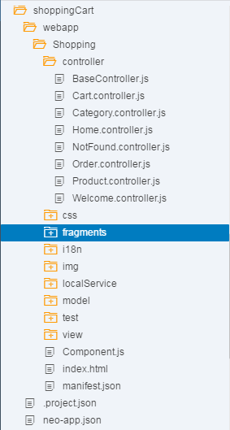

Fiori Application Naming Standard
Object Type | Naming Convention | Example / Remarks
Project Name (As created in VS Code) | zui_<FC><CA>_<TEXT> | Name will be in lower case  zui_mpu_po_report
BSP Application | ZUI_<FC><CA>_<TEXT> | ZUI_MPU_PO_REPORT
Namespace | epfsys.<Project Name> | Name will be in lower case  epfsys.zui_mpu_po_report

- <IDT> - Identifier (Hardcoded to ‘Z’)
- <FC> - Functional Code (Refer to section 4.11)
- <CA> - Component Area (Refer to section 4.12)
- <TEXT> - Meaningful free text

Version Management
For SAP Fiori objects, we will use existing ABAP version management for version control.
For any changes done to the application, the file ‘manifest.json’ is to be changed specifically the ‘applicationVersion’ attribute with an sequential number. The version contains 3 set of numbers and the numbers indicate the degree of change between versions, helping users and developers understand the significance of new releases (i.e. 2.1.4). Generally, the first number (major) signifies substantial changes or new features, the second (minor) indicates new features and enhancements, and the third (patch) represents bug fixes and minor improvements
For major enhancement, the 1st number of the version will be changed, and a new version will reset the 2nd and 3rd digit of the version number. (i.e. 1.1.12, 2.0.0, 2.1.0, 3.0.0)
For minor enhancement, the 2nd number of the version will be changed, and a new version will reset the 3rd digit of the version number. (i.e. 1.1.12, 2.0.0, 2.1.0, 3.0.0)
For each incident, the 3rd number will be changed in an incremental sequence. (i.e. 1.1.2, 1.1.3, 1.1.4).
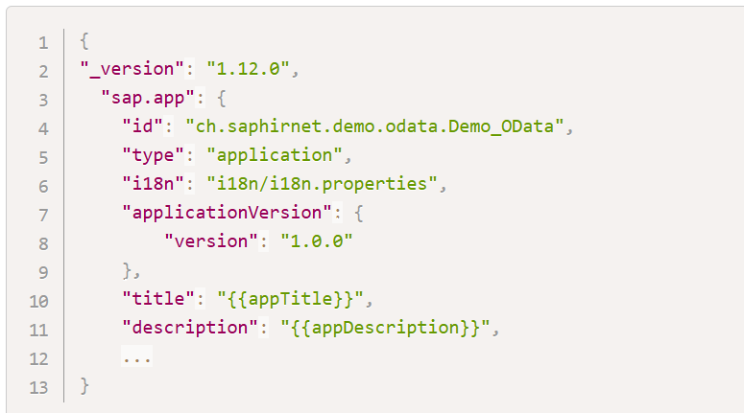

5.6.1 GitHub
Each BSP application or Fiori project will be stored in the corporate GitHub. Each project will have its own repository which will then contain branches for the ticket or RICEFW ID, development environment, test environment, and production environment.

5.6.1 Committing New Application
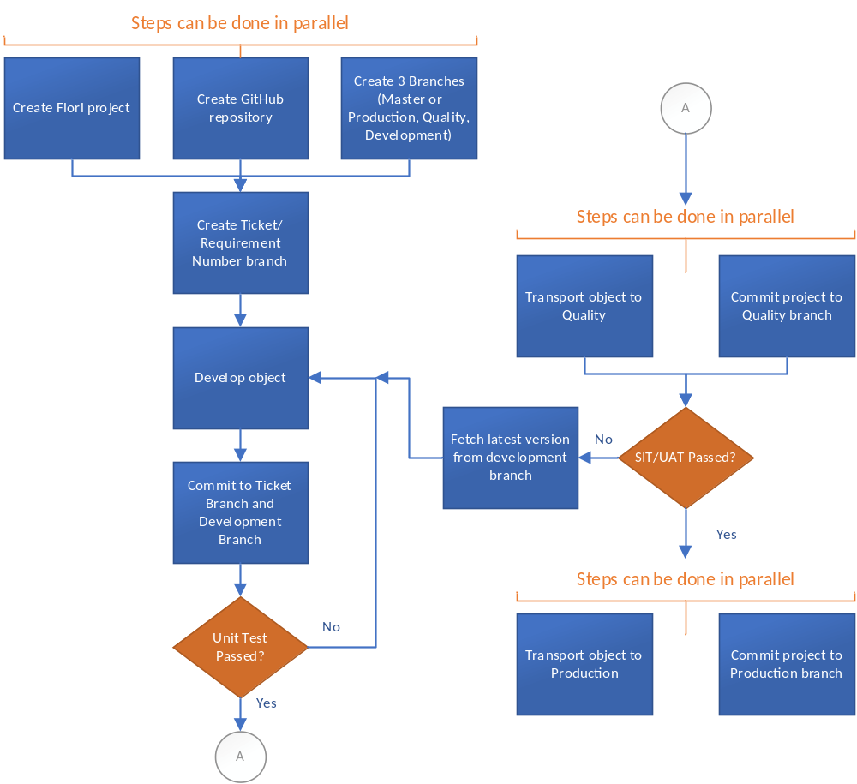

5.6.2 Committing Modified Application
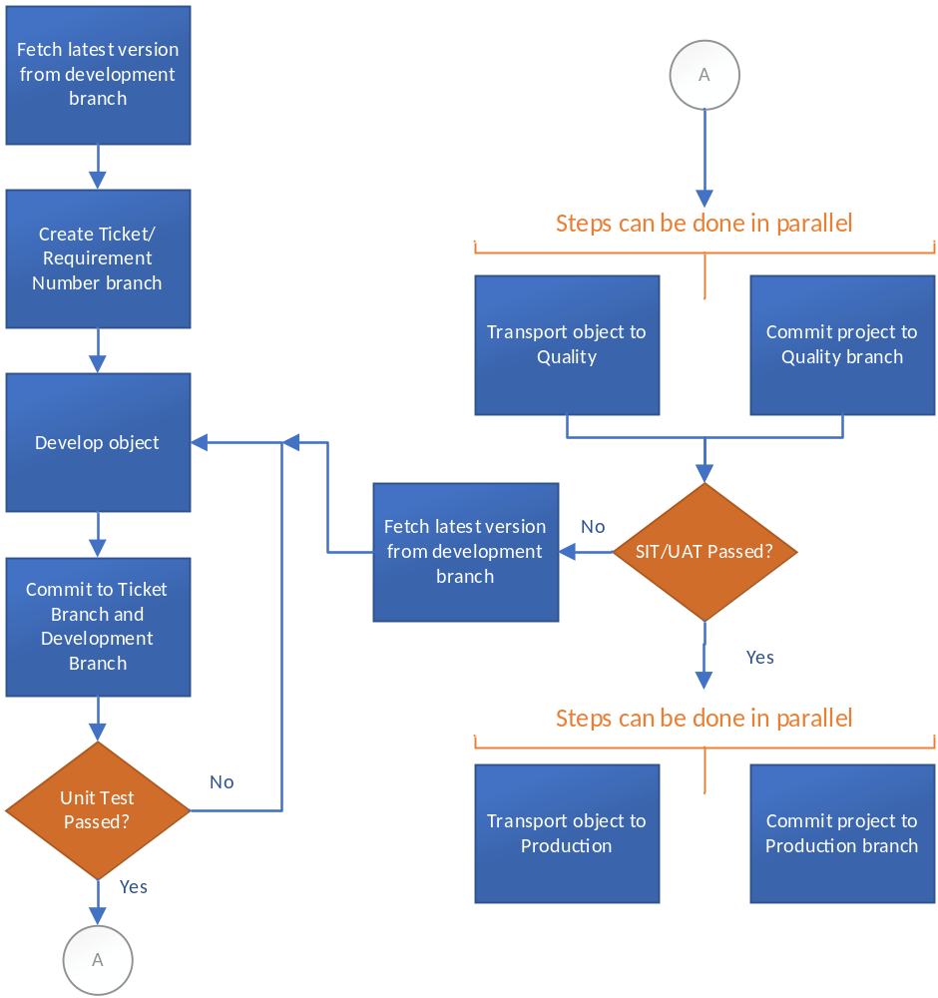

Java Script Coding Guidelines
General Guidelines
- This also means: Do not use undeclared variables. When using global variables introduced by other libraries, declare the use in a special global comment: /*global JSZip, OpenAjax */.
- Do not access internal (private) members of other objects.
- Do not use console.log() in quality and production environment.
- Keep modifications of jQuery and other embedded Open Source to a minimum and document them clearly with the term SAP modification. Such modifications may not alter the standard behavior of the used library in a way that breaks other libraries.

Code Formatting
Do not use global JavaScript variables; organize all global objects in an sap.* namespace structure, or extend the jQuery.sap object. The methodjQuery.sap.getObject(...) assists in doing so.
For ESLint check, please refer the below url https://sapui5.hana.ondemand.com/#docs/guide/41de83f642224556b8716dec2b41ce86.html
- Add a semicolon after each statement, even if optional.
- No spaces before and after round braces (function calls, function parameters).
- Use spaces after if/else/for/while/do/switch/try/catch/finally, around curly braces, around operators and after commas.
- Opening curly brace (functions, for, if-else, switch) is on the same line.
- Use "===" and "!==" instead of "==" and "!="; see the ESLint docu for special cases where "==" is allowed.
- The code should therefore look like this:
function outer(c, d) {
var e = c * d;
if (e === 0) {
e++;
}
for (var i = 0; i < e; i++) {
// do nothing
}
function inner(a, b) {
return (e * a) + b;
}
return inner(0, 1);
}
- You can use the Eclipse or VS Code default settings for the JavaScript editor, but make sure tabs are used for indentation

Internalization
The SAPUI5 framework includes internationalization functionality out of the box.
Internationalization means that all the texts of an application are available in one central location, and that a translator can easily translate all the texts into different languages. ‘i18n’ is the abbreviation for internalization.

5.9.1 Resource Bundles
The resource bundles are the actual language files that contain the key for translation and the translation itself. Those controls consume the resource bundles and therefore language data through a binding that refers to the key of the i18n text. For each language, there’s one resource bundle, plus a default resource bundle that’s used if no resource bundle exists for the language.
All resource bundles end in ‘.properties’. Their names begin with an i18n, followed by an underscore, and the language’s acronym, like ‘i18n_en.properties’. If ‘i18n_en.properties’ doesn’t exist, SAPUI5 uses the default language: ‘i18n.properties’. That’s the language determination fallback process.
Example of i18n files in different languages:
i18n_en.properties – For English language
i18n_de.properties – For German language

Resource bundles store translations as key-value pairs. A resource bundle key-value pair consists of a key and a value separated by an equal sign. The key is consistent resource bundles—it always stays the same—the value changes to each language. The keys are in camel case and the value is the actual text that should be displayed.
Example of key-value pair in English (i18n_en.properties):
appTitle=Sales Order Application
matColumn=Material Number

Example of key-value pair in Germand (i18n_de.properties):
appTitle=<German application title to be displayed>
matColumn=<German label for Material text to be displayed>

Naming Conventions
We strongly recommend using the Hungarian notation where name prefixes indicate the type for variables and object field names. But do not use the Hungarian notation for API method parameters: The documentation specifies the type in this case.
Sample | Type
sId | string
oDomRef | object
$DomRef | jQuery object
iCount | int
mParameters | map / assoc. array
aEntries | Array
dToday | Date
fDecimal | Float
bEnabled | Boolean
rPattern | RegExp
fnFunction | Function
vVariant | variant types
- Class names should use CamelCase, starting with an uppercase letter
- HTML element IDs starting with sap-ui- are reserved for UI5.
- DOM attribute names starting with data-sap-ui- as well as URL parameter names starting with sap- and sap-ui- are reserved for UI5.
Currently used IDs:
ID | Description
sap-ui-bootstrap | ID of the bootstrap script tag
sap-ui-library-* | Prefix for UI libraries script tags
sap-ui-theme-* | Prefix for theme stylesheets link tags
sap-ui-highlightrect | ID of the highlight rect for controls in TestSuite
sap-ui-blindlayer-* | ID for BlockLayer
sap-ui-static | ID of the static popup area of UI5
sap-ui-TraceWindowRoot | ID of the TraceWindowRoot
sap-ui-xmldata | ID of the XML Data Island
sap-ui-bootstrap | ID of the bootstrap script tag

Coding Issues to be Avoided
- Try not using the oEvent based syntaxes (it helps in reusing the function).
- Do not use _based API’s in your code, always use the API which is available in control documentation.
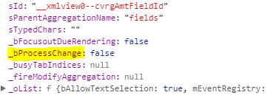
- Don't use private and protected methods or properties of SAPUI5.
E.g.:
var sText = oControl.mProperties["text"]; [Bad example]
var sText = oControl.getText(); [Good Example]
- Don't use references to global names.
Bad Example | Good Example
Access the modules directly: | Declare a dependency to sap.m.Input within sap.ui.define:
sap.ui.define(['sap/m/Button'],  function(Button) {  var fnCreateContent = function() {  // global reference on sap.m.Input, which might not be loaded yet  return new sap.m.Input({  color: ...,  });  };  }); | sap.ui.define(['sap/m/Input'],  function(Input) {  var fnCreateContent = function() {  // reference sap.m.Input via a dependency  return new Input({  color: ...,  });  };  });

- Don't use deprecated APIs.
- Don't override or add control methods.
Bad Example | Good Example
oControl.onAfterRendering = function() {  // do something  }; | oControl.addEventDelegate({  onAfterRendering:function() {  // do something  }});

- Don't manipulate the DOM structure within controls.
Bad Example | Good Example
oControl.$().find(".sapMLabel")[0].innerHTML = "reallybad"; | oControl.addEventDelegate({  "onAfterRendering": function() {  var $label = oControl.$().find(".sapMLabel");  if (/* sanity check whether the change still makes sense */) {  // TODO: re-test after UI5 updates, create automated test  $label.text("Better");  }  }  });

- Don't attach DOM event handlers.
- Don't create global IDs (when running with other views or apps).
- Don't forget about control lifecycle management.
- Don't hard code or concatenate strings that need to be translatable.
Bad Example | Good Example
Using separate texts like " you selected " and " items " in the translation file to construct sentences like: " you selected " + 10 + "items ". This would lead to a wrong word order in languages where the verb needs to be at the end of the sentence, for example. | oControl.addEventDelUsing a complete sentence including a placeholder in the translation file: " you selected {0} items ". This allows translators to change the word order and the position of the inserted placeholder value. egate({

- Don't forget about proper "this" handling.
- Don't use timeouts.
Bad Example | Good Example
Query.ajax("someData.json");  setTimeout(fnProcessResults, 300); | jQuery.ajax("someData.json").done(fnProcessResults);

SAPUI5 Adaptation
If a standard SAP Fiori application doesn’t fully support your business process or the specific needs of some of your business users, you can extend SAP S/4HANA Cloud Public Edition by creating and adapting an application variant, while the original SAP Fiori application remains available and unchanged.
You can use VS Code to create an adaptation for the standard Fiori (SAPUI5) application

Fiori Adaptation Naming Standard
Object | Naming Standards
Project Name | <IDT><FC>.<APP>.<TEXT>  E.g. zf.app.manage.coa (Manage Chart of Accounts)
Namespace | epfsys.<Project Name>  E.g. epfsys.zf.app.manage.coa

- <IDT> - Identifier (Hardcoded to ‘Z’)
- <FC> - Functional Code (Refer to section 4.11)
- <APP> - Hardcoded to ‘APP’
- <FREETEXT> - Text should be almost the same as the application name but not strictly the same as app name might be longer than what can be accommodated
Note that the project name and namespace should be in lower case and period (“.”) will be used as a separator

Gateway Development Process
This section provides details about the gateway development process.

Create New Service Endpoint
- Create new project using SEGW following naming standards
- Register your new endpoint in the Gateway system
- Generate project.

Business API Interface Structures
- create the API interface DDIC structures in SE11
- reuse existing structures (instead of including structures) as these can be mapped to complex types
- use meaningful, non-SAP field names, which clearly describe the field semantic in pure English. A good example would be FirstName instead of VNAME

Create GW Object Structure in DDIC
- Create new Entity/EntitySet in Service Builder by importing the DDIC structure
- Adjust field names if required, however properly_named_fields will be automatically UpperCamelCase
- Optionally remove some attributes if not required on the GW layer, this will NOT cause any complications
in the mapping
- Select key fields

Build Optional Association Between GW Objects
- In service builder build associations one way using the wizard
- Create navigation properties for both directions

Generate GW service
- Keep in mind that it will take down any existing service, this could cause interruptions to UI developers and testers.

Implement relevant methods in the DPC_EXT class
- read key/filter parameters or the actual object structure
- process paging / sorting parameter
- call business layer to execute relevant business action, pass all key, sort, filter parameter
- return object or exception.

Test changes
- Test changes using GW Client: /IWFND/GW_CLIENT to ensure generation was successful
and changes are adopted or use tools such as POSTMAN

Extensibility Guidelines

Decision Guidelines for Extensibility Options
Scenario | Dev Tier | Options | When to Use | Remarks
New CDS View | Tier 1 | Use ADT for CDS Development | Default option | Developer Extension
New Report | Tier 1 | Use Custom Analytical App | Analytical report and if all fields are available in SAP released objects | Key-User Extension
New Report | Tier 1 | Use Fiori Elements | Fiori app with basic annotations | Developer Extension
New Report | Tier 3 | ABAP Report | Background execution  Read or create file in application server  Form print programs
New Enhancements | Tier 1 | Custom Logic App / BAdI In SCFD_REGISTRY | Default option | Key-User Extension
New Enhancements | Tier 3 | BAdI Implementation / User Exit / Implicit Enhancements | BAdI is not in BAdI extensibility registry  CAR environment has no User Extensibility
New Custom Field | Tier 1 | Custom Fields App | Default option | Key-User Extension
New Custom Field | Tier 3 | Append/Include Structure | No available business context in Custom Fields app  CAR environment has no User Extensibility
New Workflow | Tier 1 | Manage Workflows App (Flexible Workflow) | Default option
New Workflow | Tier 3 | Classical Workflow (PFTC) | Complex scenarios like parallel approvals, version management, rework process, etc.
New Fiori App | Tier 1 | Fiori Elements | UI can be covered by annotations  Basic CRUD functionality | Odata using SEGW via SADL
New Fiori App | Tier 1 | Freestyle SAPUI5 | Complex UI requirements that use elements not covered by existing CDS annotations | Odata using SEGW and SAPUI5 will be developed in VS Code
Existing Custom Fields | Tier 1 | Migrate to Custom Fields (SCFD_EUI) | Few objects that are using the fields are impacted | Key-User Extension
Existing Custom Fields | Tier 3 | Retain existing solution | Several objects are impacted  No released business context for involved object
Existing Enhancements | Tier 1 | Migrate to Custom Logic App | Existing logic involved released ABAP artifacts and if relevant BAdI exists in Custom Logic app
Existing Enhancements | Tier 3 | Retain existing solution | No corresponding Custom Logic BAdI available  Logic involves unreleased ABAP artifacts and access to memory ID
Existing ABAP Reports / Web Dynpros / Forms | Tier 3 | Retain existing solution and publish it on Fiori Launchpad
Existing ABAP Reports / Web Dynpros / Forms | Tier 1 | Redevelop ABAP Reports as CDS / Fiori Applications | When there’s a need to utilize the report output for further Odata capabilities | Developer Extension/Key User Extension
Existing Interfaces | Tier 3 | Retain existing solution

Key User Extensibility

UI Flexibility
UI Flexibility can be used if the requirements fall on the ff. scenarios:
- Hide fields in a form, table, or filter, hide groups and areas
- Rename labels
- Add field to UI from field repository
- Move form field or UI group by drag & drop, create new groups and move fields into
- Combine fields into one line, split combined fields
- Define new filter and variants for tables

Custom Field
Custom Field app can be used if the requirements fall on the ff. scenarios:
- Create and edit custom fields (extend the SAP table, application, CDS views and OData services)
- Delete an existing custom field
- Manage the usages of a custom field such as other UIs, reports, forms, service interfaces, processes, search

Custom Logic
Custom Logic app can be used if the requirements fall on the ff. scenarios:
- Enhance standard transactions
- Implement Business Add-Ins to extend functionality of standard applications
Based on Decision Guidelines (section 6.1), this is the default option when extending functionalities of standard transactions and applications instead of using classic user-exit, BAdI, and enhancements.

Custom Analytical Queries
Custom Analytical Queries app can be used if the requirements fall on the ff. scenarios:
- Create a query based on a released SAP analytical data source (CDS views of type cube) or a custom analytical data source
- Copy a query from a SAP delivered standard analytical query
- Add or remove or customize field defined in the query (defining new labels for a field, display data as key or text, show or hide result rows etc.)
- Add or remove filters (pre-configured fixed value filters or user input values filters)

Developer Extensibility

Overview
Developer extensibility allows ABAP developers to connect to an SAP S/4HANA system using the ABAP Development Tools (ADT), however, extensions are developed using the new ABAP Cloud development model. This is ideal for scenarios where you need to build cloud-ready extensions and applications.
For this type of extensibility, it’s suggested that we use ABAP Restful Application Programming model or RAP which is designed for creating applications that are ready for deployment in the cloud, making it ideal for modern, scalable solutions. RAP supports the development of SAP Fiori elements apps, ensuring a modern and intuitive user experience. RAP also leverages CDS for defining semantically rich data models, which are crucial for building robust and efficient applications.
For RAP developments, CDS views are used as the data models. RAP relies on the annotations within the CDS view to generate the user interface using SAP Fiori elements and uses behaviors to implement the service logic for the application.

CAR Extensibility

Overview
As comprehensive as the SAP Customer Activity Repository POS transaction data model is, you can enhance it if you need to store non-standard data directly in each transaction record.
For example, you can store comments that a cashier enters about a particular POS transaction directly in the POS transaction log. There are no standard fields to store cashier comments in the TLOG data model, therefore you use an extension segment.
Extension segments support customer-specific fields by storing them without having to alter the table definition. The extension segment concept also provides customers with the flexibility to store and process the extensions together with the rest of the transaction.
You may refer to this link for the SAP guideline on CAR extensions.

